# **INFOSYS320 2017 S2 – Practice Lab Test 2**

# Aim

Plot data from Cloud into 3D

# Resources

Start with “HelloUnity_Final – Products.zip” in Files/Lab material on Canvas.

Use URL <http://infomgmt192.azurewebsites.net/tables/Mountain?zumo-api-version=2.0.0>

See endpoint at

<http://infomgmt192.azurewebsites.net/swagger/ui/?url=http://infomgmt192.azurewebsites.net/swagger>

# Tasks

|  |  |  |
| --- | --- | --- |
|  | **Tasks** | **Allocated mark** |
| 1 | Create a spinning cube for each Mountain | 30 |
| 2 | Attach the MountainName to it | 5 |
| 3 | Place Cubes at their X, Y, Z coordinates | 10 |
| 4 | Stop them spinning | 5 |
|  | Set the size of each cube | 10 |
|  | Set Prefab based on Symbol value | 10 |
| 5 | Set a breakpoint and examine values in array of Mountains | 5 |
| 6 | Annotate the code in the Sketch.cs below explaining each line. Explain each concept (int x=0 means define variable x as an integer and set to 0) once. | 20 |
| 7 | Commit all your work (including your Word document) to Github at least twice and then at the end | 5 |

# **Submission**

Submit the annotated code with your Name UPI, and ID to your test supervisor.

Submit to canvas:

1. For each step above place a screenshot in a Word document.
2. Include your GitHub URL in your document.
3. Zipped up Unity3D project to Canvas.

GitHub:

<https://github.com/troy-anderson>

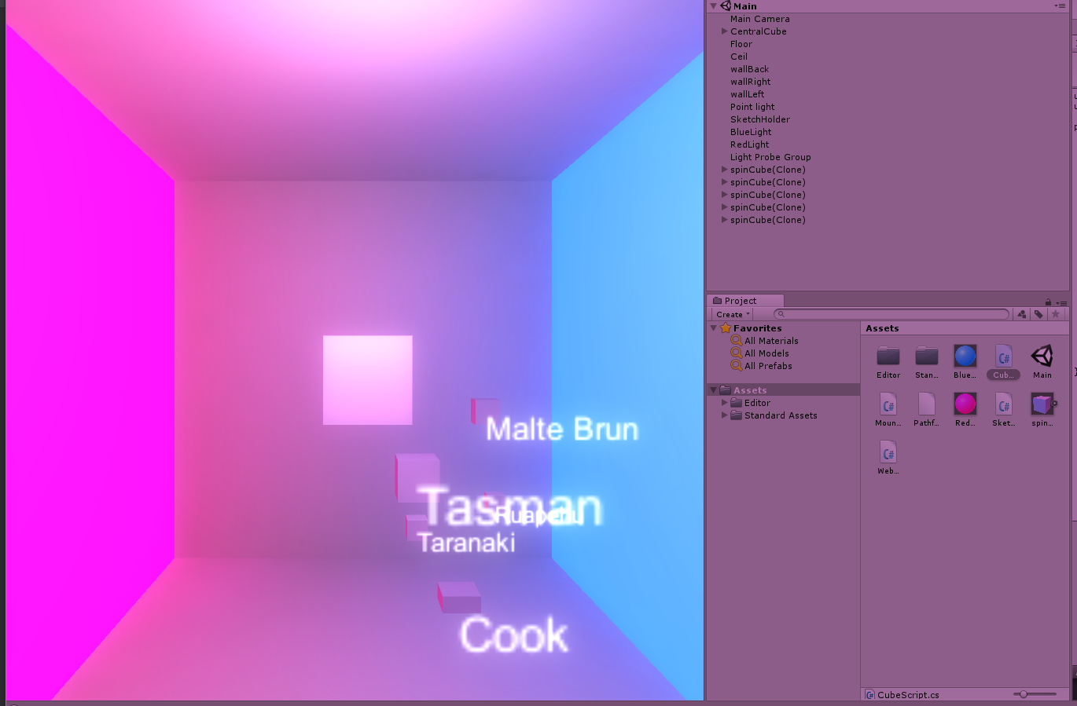Unity Game View:

Note: I reduced the size of all cubes to 1/5th of the size provided in the DB (for a better screenshot), the code in is sketch.cs

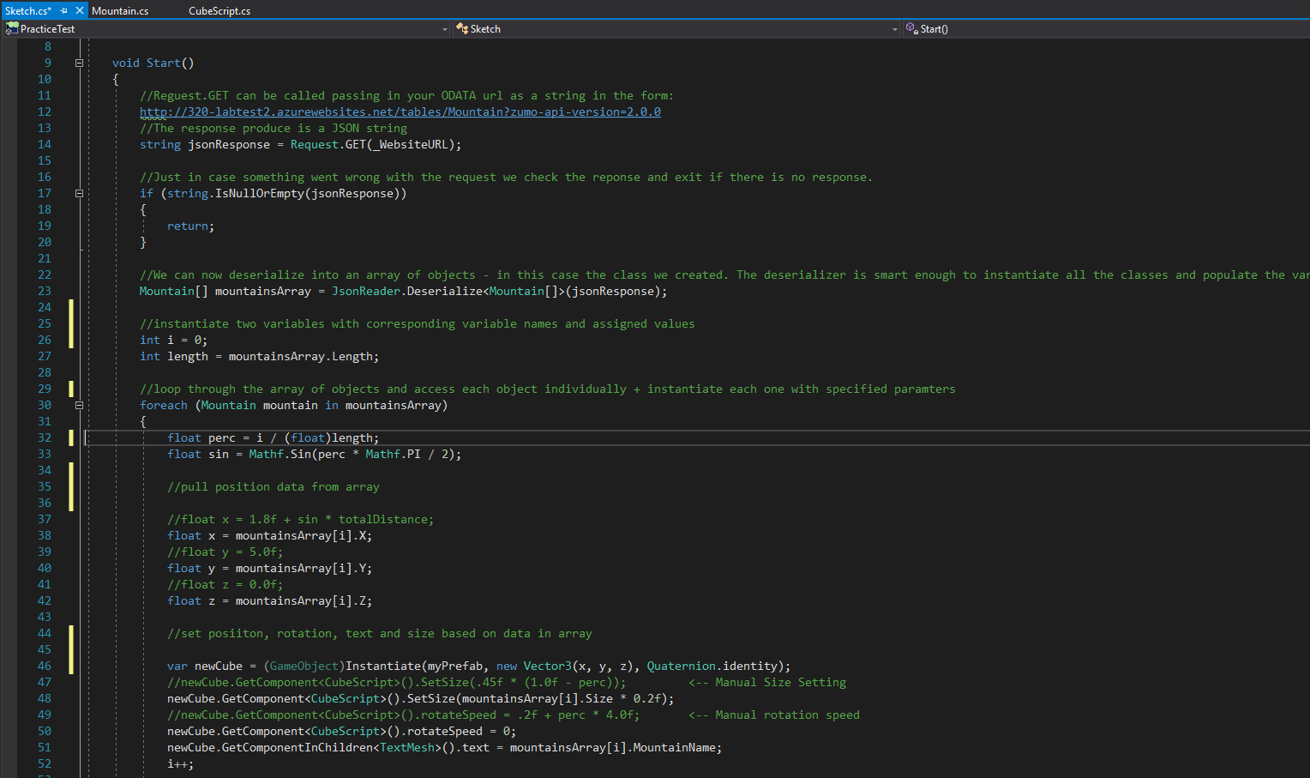Sketch.cs (annotated):

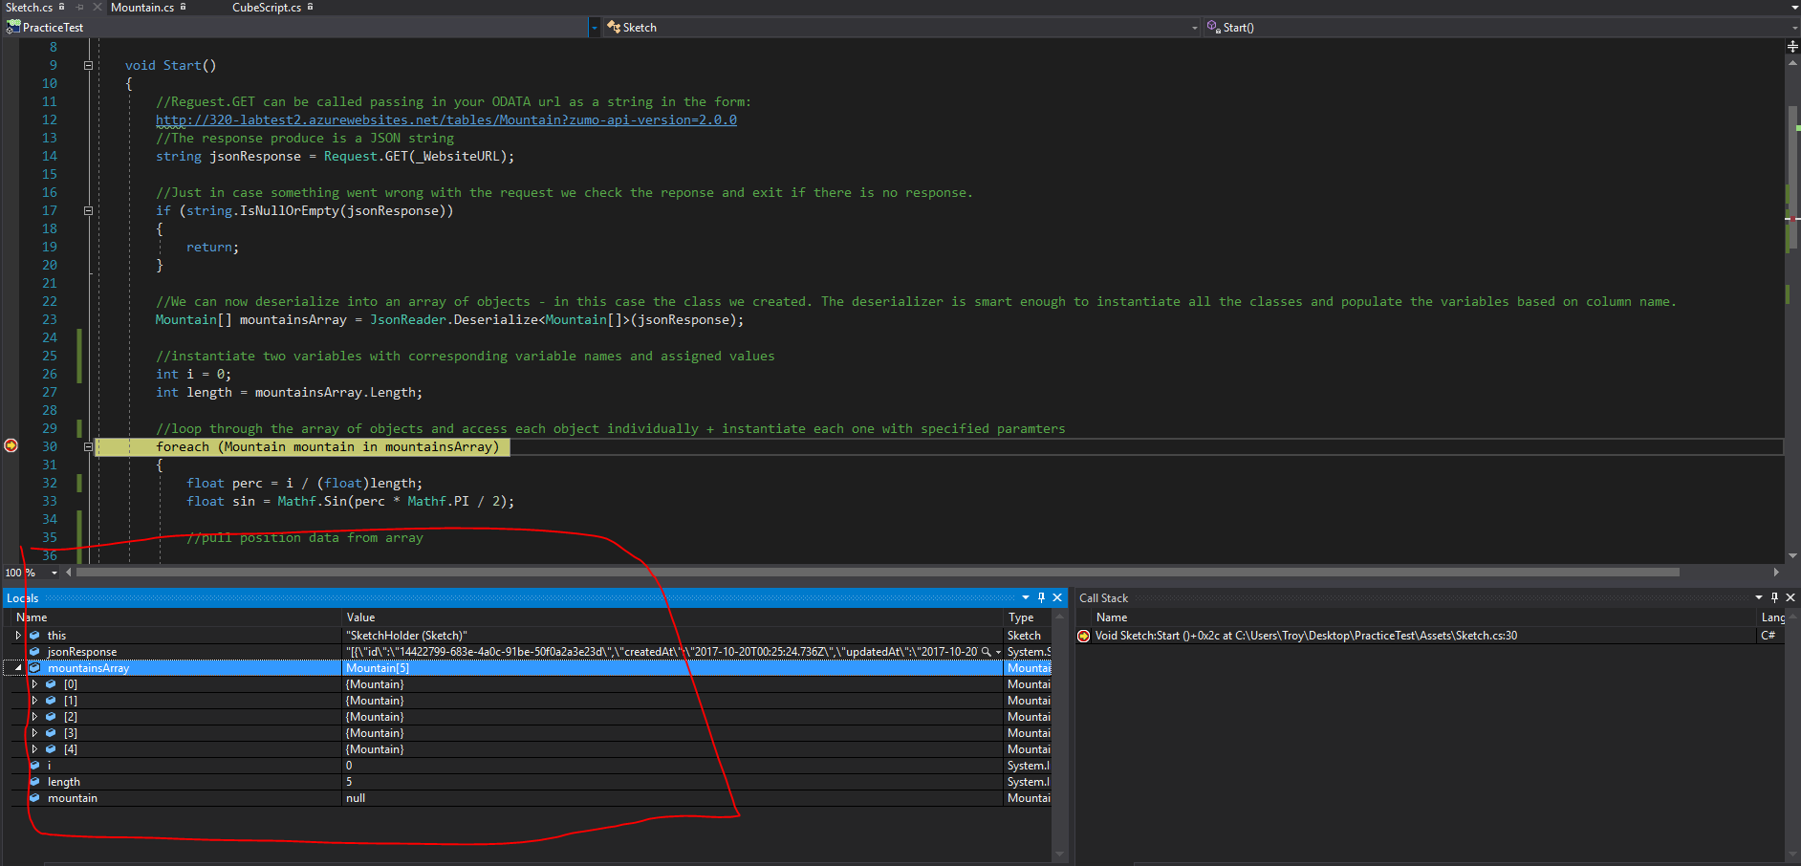Sketch.cs with Breakpoint:

Table Data API call:

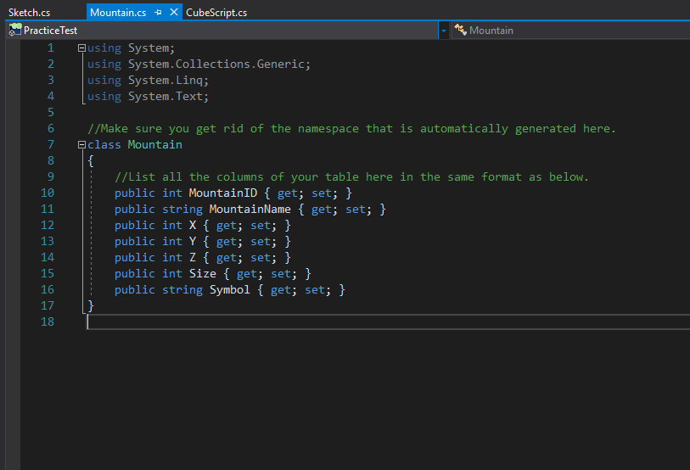

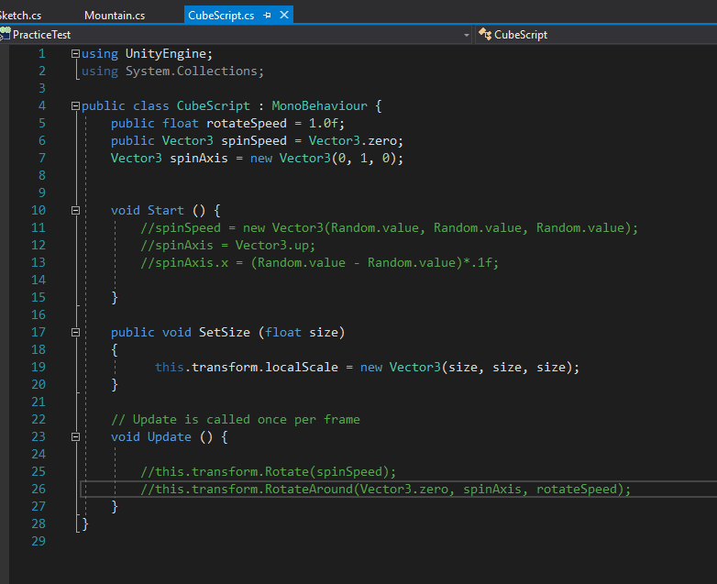CubeScript.cs: